5.3.2 Polar Worksheet

- Find the area of each of the following shaded regions.
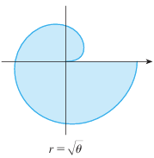
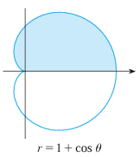
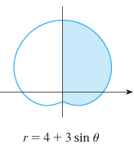
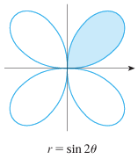

- Consider the polar curve . Find the area enclosed by one petal of this polar curve.

- Find the area of the region enclosed by one loop of

- Find the area enclosed by the polar curve

- Find the area which lies inside and outside .

- Setup, but do not evaluate, an integral(s) that represent the area that lies inside the first curve and outside the second curve.
- and

- and

- and

- Find a way to compute this area by seeing it as an area between two curves.

- Find a way to compute this area by seeing it as an addition and subtraction of various areas. (That is differently than the way the area was computed in part (i)).

- and

- and

- Setup, but do not evaluate, an integral(s) that represent the area of the region that lies inside both curves.
- and

- and

- and

